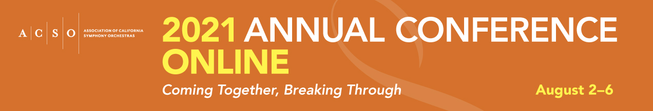
Captions

Short Caption: Registration is now open for ACSO’s 2021 Annual Conference Online! Instead of traditional breakout sessions, the week-long virtual conference will feature a series of plenary talks delivered by preeminent change-makers, thought-leaders, advocates, artists, and innovators. The sessions are designed to help orchestra professionals apply the lessons learned during the past sixteen months as they work towards relaunching live performances.

While ACSO serves classical music organizations, the conference is open to all arts professionals. Orchestra professionals and musicians and arts workers outside of California are also welcome to attend as conference will focus on contemporary issues relating to the both the national orchestra field and the larger arts sector.

Registration is offered on a “pay what you can” basis for members and non-members alike. To view the schedule, learn more about the plenary sessions and speakers, and registration, visit www.acso.org/conference.

Long Caption: Registration for ACSO’s Annual Conference Online – Coming Together, Breaking Through – is now open! Conference will take place this year as a one-week virtual event from August 2-6, 2021.

The value of attending the conference is estimated at $25 per person. To make conference participation accessible to all, registration is offered on a “pay what you can” basis for members and non-members alike. There is a complimentary option if needed, or several suggested payment tiers, starting at $25, for those who feel inspired and are able to support ACSO’s programs.

The theme of the 2021 Annual Conference is Coming Together, Breaking Through. The sessions are designed to help us lift our heads from the daily grind of solving problems and adapting to non-stop change, and come together as a community to hear from new and impactful voices, think more deeply, and make breakthrough revelations about the big-picture issues and opportunities for our field as we move into a period of recovery.

While ACSO serves classical music organizations, the conference is open to all arts professionals. Orchestra professionals and musicians and arts workers outside of California are also welcome to attend as conference will focus on contemporary issues relating to the both the national orchestra field and the larger arts sector.

To view the schedule, learn more about the plenary sessions and speakers, and registration, visit www.acso.org/conference.

Social Media
Facebook: @ACSOposts; www.facebook.com/ACSOposts
Instagram: @acso_gram; www.instagram.com/acso_gram/
Twitter: @ACSOtweets; www.twitter.com/ACSOtweets
LinkedIn: www.linkedin.com/company/acso-linkedin

Hashtags: #ACSOcon #ACSO2021

Contacts

For Conference registration questions- conference@acso.org
For membership questions- office@acso.org
For marketing questions- communications@acso.org

